DAD 220 Project Two Template

Overview
Review the scenario for this activity in the guidelines and rubric. Then complete the steps below as you work through the directions for this activity. Replace the bracketed text with your screenshots and responses to the prompts. Size each screenshot and its explanation to fit approximately one-quarter of the page with the description written below the screenshot. Review the Template Screenshot Example linked in the guidelines and rubric for this assignment to see an example of how screenshots for your assignment should look.

RMA Report
Write a report to respond to the manager’s requests. In the report, you should complete the following actions:

- Summarize the data you’ve been working with.
- Identify key information that will help the company streamline operations.

Your report should explain your findings in a way nontechnical stakeholders can understand and use.

Use the steps below to capture the required data and produce the analysis report.

- Begin by writing SQL commands to capture specific usable data for your analysis. You already preloaded the data you need into Codio.
- Specifically, the product manager wants you to complete the following analysis:

  - Analyze the number of returns by state and describe findings to include in your report.
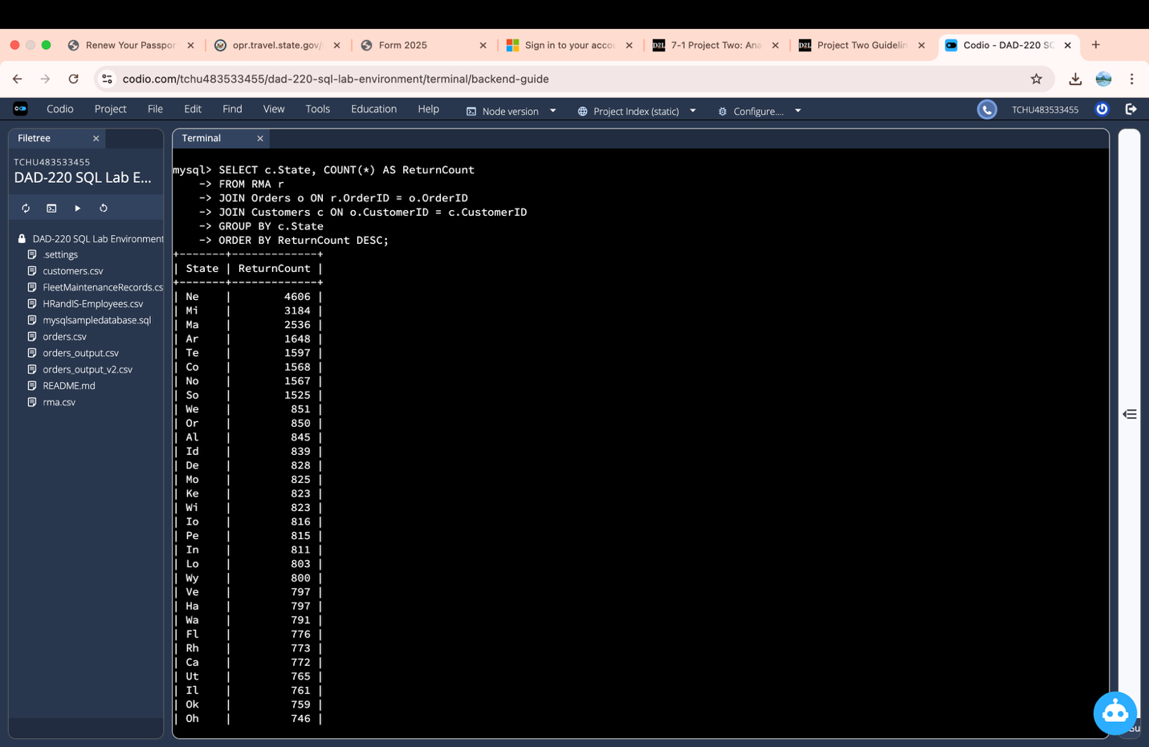
This query joins RMA, Orders, and Customers to count how many returns came from each state, then sorts the states from highest to lowest. The highest-return states show where return activity is most concentrated, which helps prioritize operational follow-up and support in those locations.

  - Analyze the percentage of returns by product type and describe findings to include in your report.

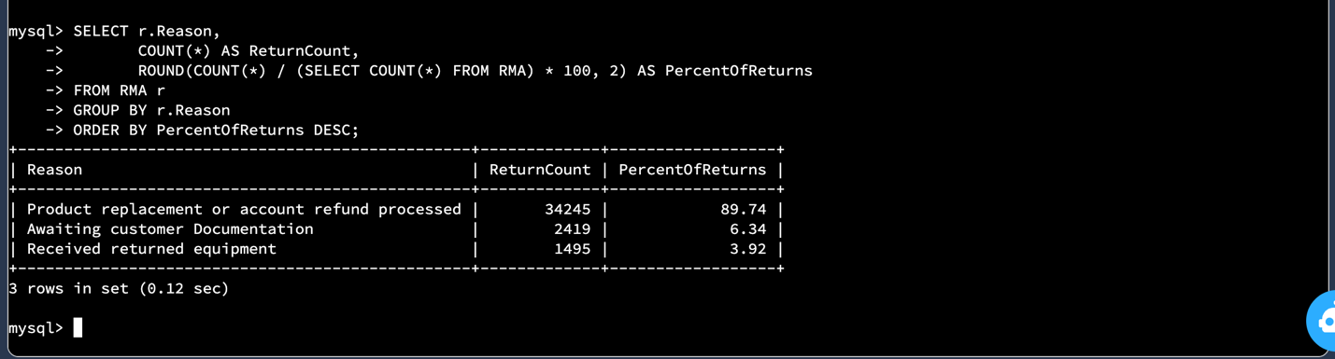
This query groups returns by reason and calculates the percentage each category represents out of total RMAs. Product replacement or account refund processed accounts for 89.74% of all returns, making it by far the most common return type and the primary area where operational improvements could reduce overall return volume.

- Write a report to clearly summarize your RMA data analysis for stakeholders. When you summarize the results, consider the following questions:

  - How does the data provide the product manager with usable information?
  - What are the potential flaws in the data that has been presented?
  - Are there any limitations on your conclusions or any other ways of looking at your findings that you haven’t considered? Clearly communicate your findings to stakeholders.

This report analyzed Return Merchandise Authorizations (RMAs) to identify patterns that can support operational decision-making. First, returns were analyzed by state to determine where return activity is most concentrated. The results show that Ne (4,606 returns), Mi (3,184 returns), and Ma (2,536 returns) account for the highest number of returns. These states may require closer review of shipping processes, fulfillment procedures, or customer service interactions to determine whether operational adjustments could reduce return volume.
Second, returns were analyzed by reason to determine which type of return activity is most common. The results indicate that “Product replacement or account refund processed” accounts for 89.74% of all returns, making it the dominant category. This suggests that most returns result in replacements or refunds, and reviewing the underlying causes of these transactions could have the greatest impact on reducing overall RMA volume. One limitation of this analysis is that it examines return counts and percentages but does not compare them to total sales volume. High return numbers may reflect high sales in certain states rather than operational issues. Additionally, the dataset does not provide detailed root-cause information or time-based trends, which limits deeper analysis.

